Title

Brad Cannell

April 8, 2016

# Heading 1

### Heading 3

#### Heading 4

##### Heading 5

###### Heading 6

To edit the default formats for this template file, select the Home ribbon tab and in the Styles group click the Styles Pane launcher (to the right side).

In the Word document, reformat the text elements as you like. In the Styles window, click on the style drop-down menu and select Update Title to match selection.

Save the template

In order to use it as a style template for an Rmd document, it must be copied and pasted into the same directory as the R Markdown file.

In the Rmd front matter, add new output arguments to format the report using the styles reference document.

|  |  |
| --- | --- |
| **Column Header** |  |
| Row Header | Table body |

---  
title: "Test Report"  
author: "Your Name"  
date: "July 3, 2015"  
output:  
 word_document:  
 reference_docx: word-styles-template-01.docx  
---  
  
My report starts here.

More information is available here

browseURL("http://rmarkdown.rstudio.com/articles_docx.html")

## R Markdown

This is an R Markdown document. Markdown is a simple formatting syntax for authoring HTML, PDF, and MS Word documents. For more details on using R Markdown see <http://rmarkdown.rstudio.com>.

When you click the **Knit** button a document will be generated that includes both content as well as the output of any embedded R code chunks within the document. You can embed an R code chunk like this:

summary(cars)

## speed dist   
## Min. : 4.0 Min. : 2.00   
## 1st Qu.:12.0 1st Qu.: 26.00   
## Median :15.0 Median : 36.00   
## Mean :15.4 Mean : 42.98   
## 3rd Qu.:19.0 3rd Qu.: 56.00   
## Max. :25.0 Max. :120.00

## Including Plots

You can also embed plots, for example:

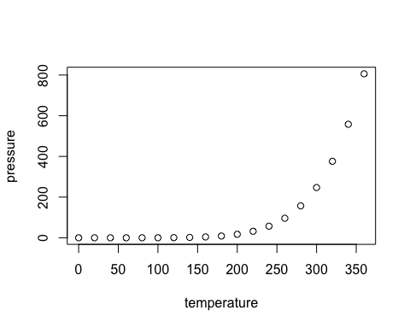

Note that the echo = FALSE parameter was added to the code chunk to prevent printing of the R code that generated the plot.